Heritage Statement
FLAT 2 Bitterbeck Close, COCKERMOUTH, Cumbria, CA13 9NN
1.0 Location
Flat 2 Bitterbeck Close is a top floor flat contained within a circa 18th century building.
The building frontage is 11-23 Market Place, which is Grade 2 listed, listing number 1144720.
5161 MARKET PLACE (South side) Nos 11 to 23 (odd)
NY 1230 1/81 25.6.73.
II GV
2. Three storeys, cement rendered. No 25 has convex front. Small late Victorian shop fronts, Nos 13 and 15 shop fronts with dentilled cornice. 12-paned sash windows above. Arched carriage entrance to No 13.
All the listed buildings in Market Place form a group with Kirkgate Corner, St Helen's Street.
Listing NGR: NY1234630725

2.0 The Building.
2.1 External
The property is constructed from sandstone with a smooth render on the front elevation (presumed lime render) and a cementitious rough cast render to the rear. An extension was added to the rear of the building in the 1970’s and the bathroom of the property forms part of this extension and is believed to be of cavity wall construction.
The windows of the property are 12 paned timber sash windows at the front and 1 over 1 timber windows to the rear. The entrance door to the flat is on the rear and is a timber door.
The property has a roof covering of traditional slate.
2.2 Internal
Internally the property has little historic features. The windows of the front elevation have secondary glazing units fit, and there are no panelling of shuttering details . To the rear the windows are single paned with no features around the reveals.
The internal walls are a gypsum plaster applied directly to the sandstone wall.
Please see section 5.0 for photos of the existing building.

3.0 The Proposals.
We are proposing the following works.
3.1 Internal Wall Insulation.
We propose the Installation of Internal Wall Insulation to the internal face of the external walls of the flats. This will involve mounting stud work to the internal walls and installing around 50mm thick insulated plasterboard. We will include a vapour control layer on the warm side of the insulation to prevent issues with condensation and mould forming on the external wall behind insulated plasterboard.
Reasoning.
The property is currently thermally poor. The current EPC band for the property is 64 D. In line with the government ambition set out in the Clean Growth Strategy to see as many properties as possible reach EPC C, we would like to improve the property to EPC band C. Reaching this target will not be possible unless we insulate the external walls.

4.0 Impact Assessment
4.1 Internal Wall Insulation.
Impact – We believe this measure will have no negative impact on the building. We will incorporate a vapour control layer on the warm side of the insulation to prevent condensation and mould forming on the external wall behind the insulation. In addition, we will maintain a minimum 30mm air gap between the solid wall and the new stud wall to allow any moisture to evaporate.
There are no significant details around walls, ceilings and windows openings that can be affected by the internal insulation detailing. We have determined the floor joists are not embedded into the external walls; therefore, these will not be at increased risk of timber degradation as a result of installing internal wall insulation.

5.0 Photographic Schedule
5.1 External

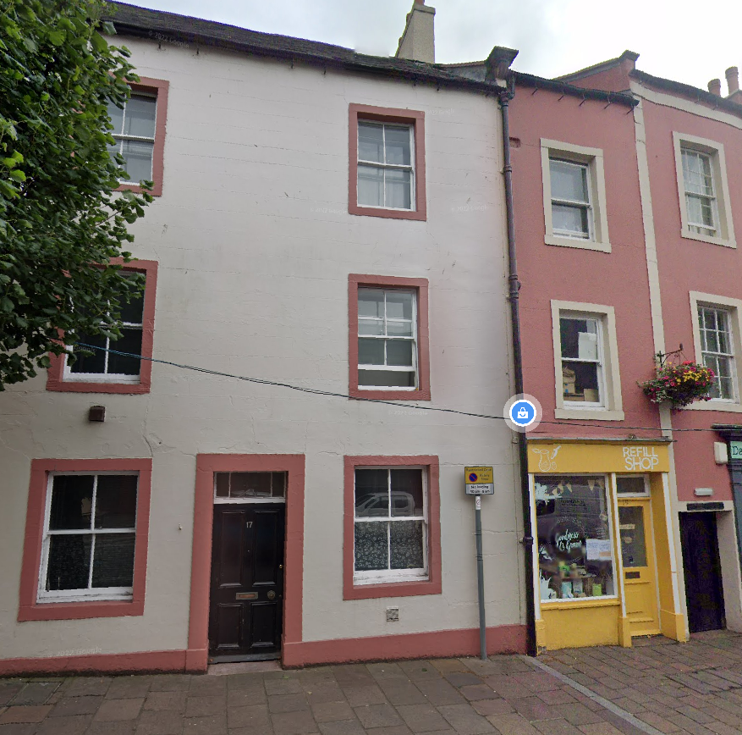

5.2 Internal
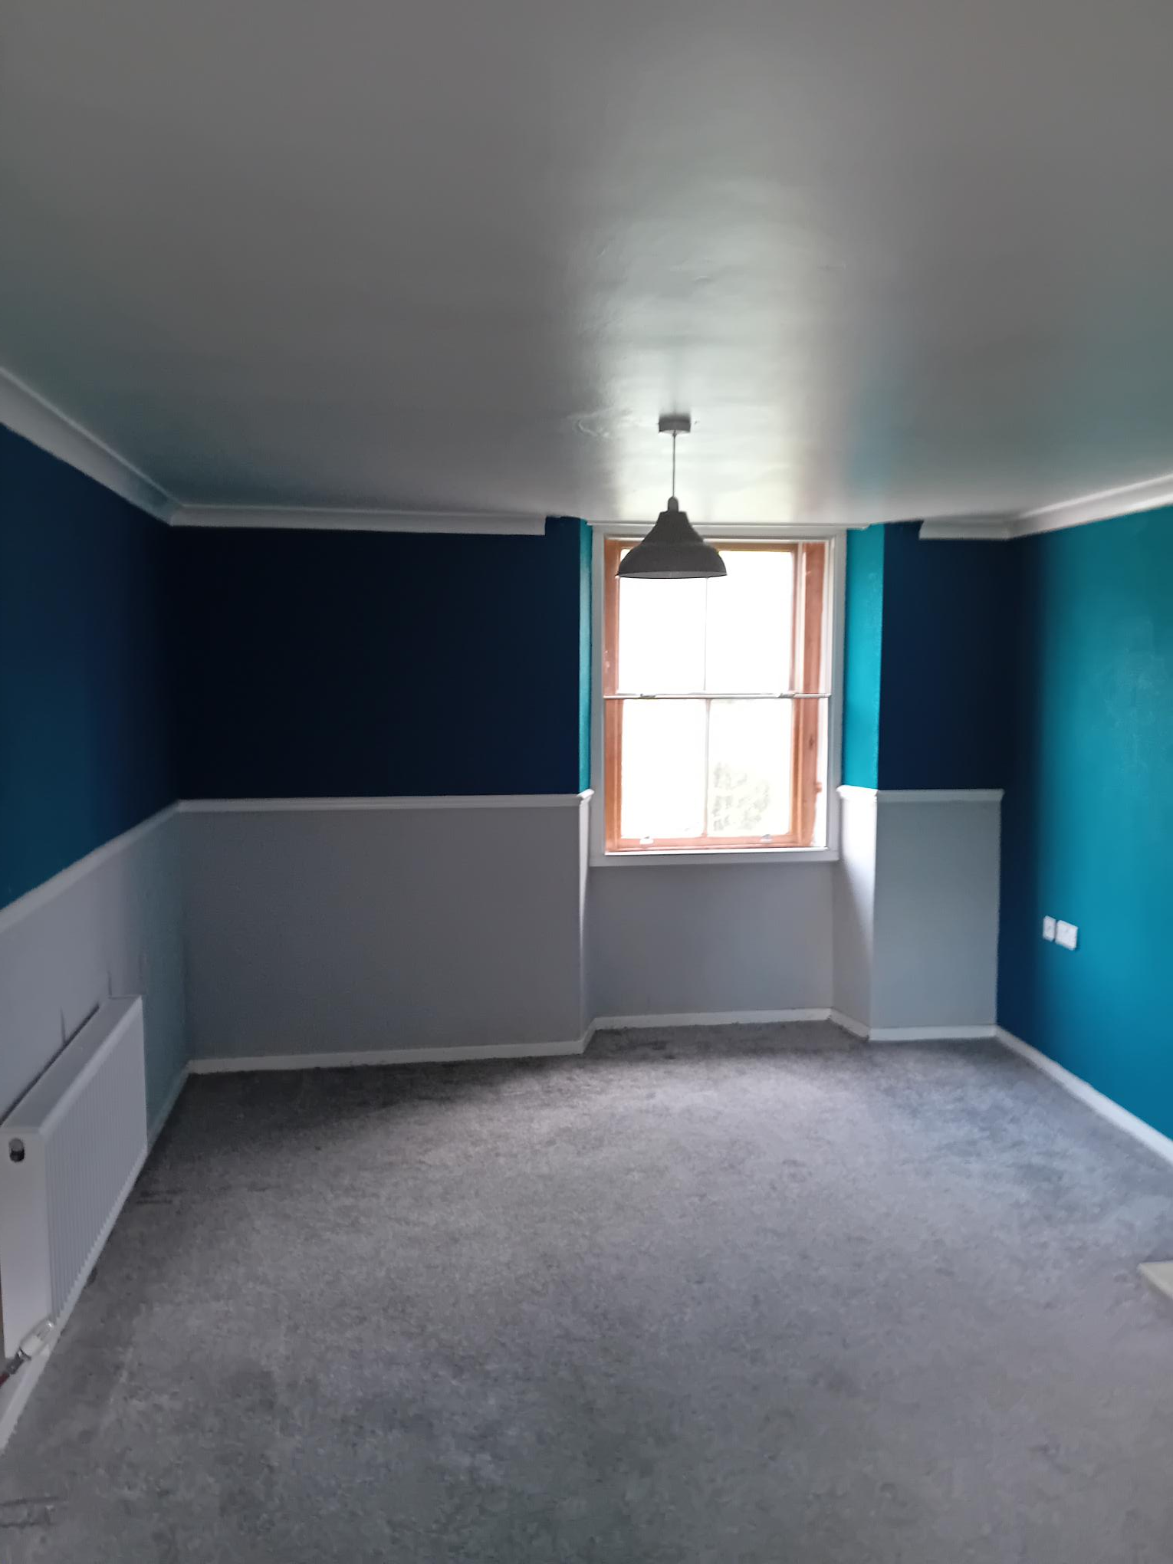

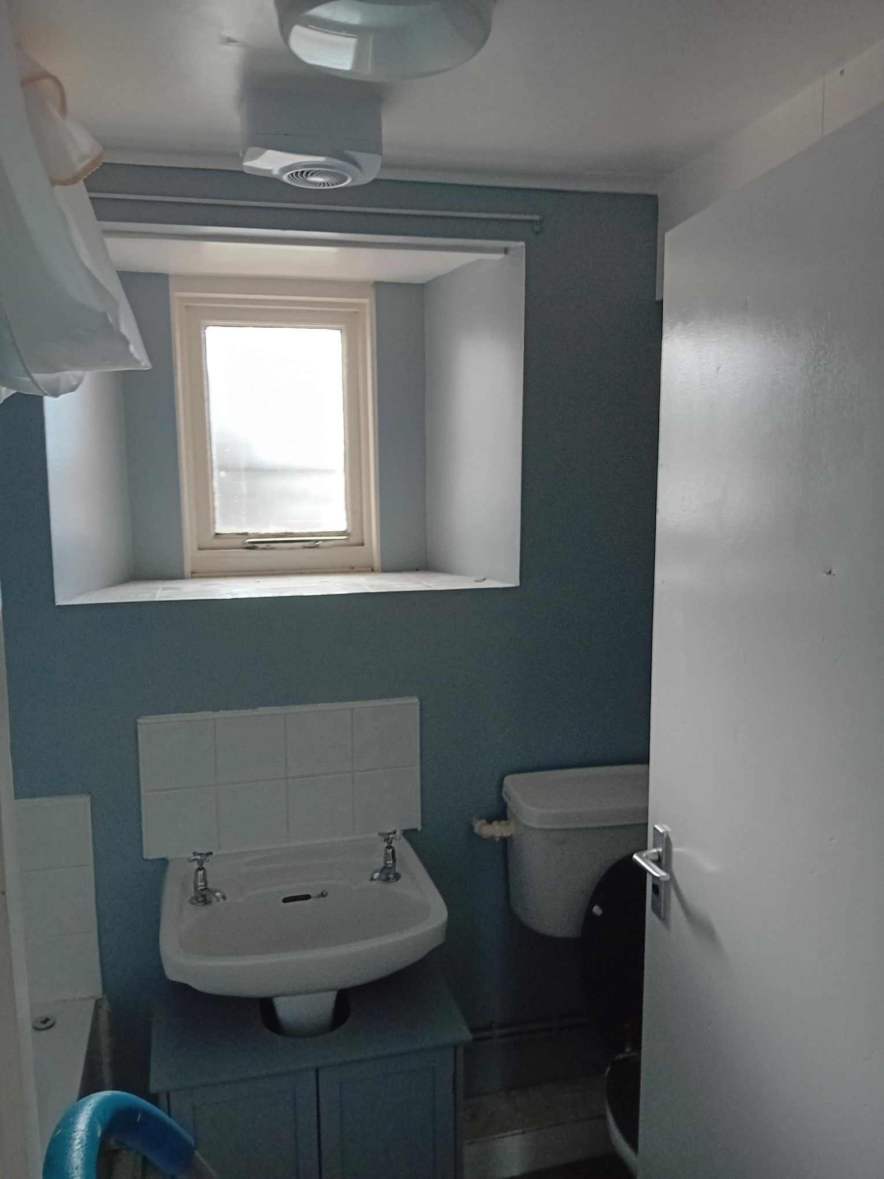

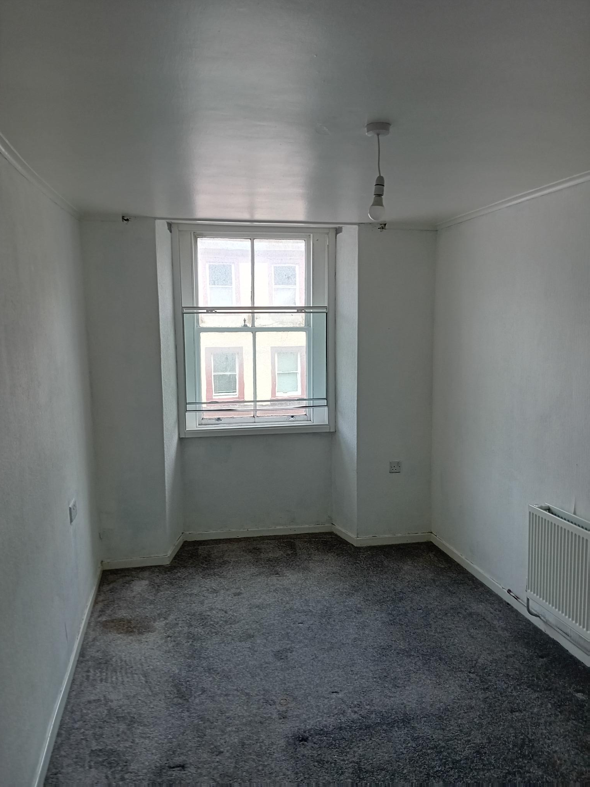

5.3 Celling

